**Size of Binary Tree:-**

Given a binary tree of size **N**, you have to count number of nodes in it. For example, count of nodes in below tree is 4.

        1  
     /      \  
   10      39  
  /  
5

**Input:**  
First line of input contains the number of test cases **T**. For each test case, there will be only a **single** line of input which is a **string** representing the tree as described below:

1. The values in the string are in the order of **level order** traversal of the tree where, numbers denote node values, and a character “N” denotes **NULL** child.
2. For example:  
   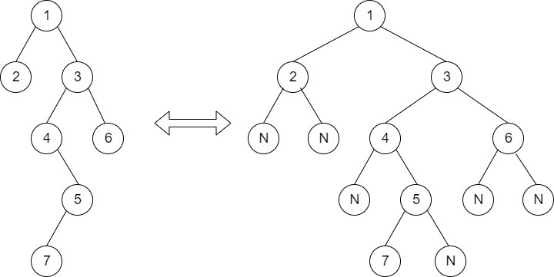  
   For the above tree, the string will be: 1 2 3 N N 4 6 N 5 N N 7 N

**Output:**  
For each testcase in new line, print the number of nodes.

**User Task:**  
Since this is a functional problem you don't have to worry about input, you just have to complete the function **getSize()**.

**Constraints:**  
1 <= T <= 30  
1 <= N <= 104  
**Example:  
Input:**  
2  
1 2 3  
10 5 9 N 1 3 6

**Output:**  
3  
6

**Explanation:  
Testcase 2:**Given Tree is :  
                                10  
                             /        \  
                           5          9  
                             \       /     \  
                              1    3       6  
There are six nodes in the tree .